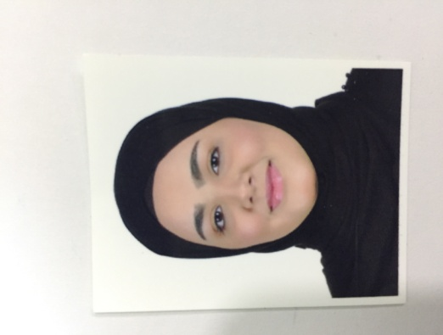g

|  |
| --- |
| **Personal Details** |

|  |  |
| --- | --- |
| Name  Nationality  Date of Birth  CPR No.  Address  Phone Numbers  E.Mail  Marital Status | : Ghafrun Jaffar Abdul Karem Hasan  : Bahraini  : 17 Feb 2000  : 000205443  : Villa 1609, Road 844, Block 608 Kingdom of Bahrain  : +973 39970130    : gufrun172@gmail.com  :single |

**Practical Experience**

* Knowledge of Microsoft Office ( Word,Excel,PowerPoint .. )

**Strengths & Positive Traits**

* The ability to work even under continuous pressure
* Excellent interpersonal skills with extensive social relationships
* Excellent communication & public relation skills.

**Qualifications School**

* Sitra Secondary School for Girls 2016-2018

**Hobbies and Interests**

* Reading

* Using Computer & internet

**Languages**

English, Arabic